Website Traffic Analysis – Executive Summary & Project Documentation
Name: Prem Pandey
Internship: Alfido Tech Data Analytics Internship
Project: Website Traffic Analysis
Tools Used: Python, Pandas, Matplotlib, Jupyter Notebook

Project Links
GitHub Repository: https://github.com/PremPandey9/Website-Traffic-Analysis
Dataset Source: https://www.kaggle.com/datasets/bhanupratapbiswas/website-traffic-analysis

Executive Summary
This project analyzes website traffic data to understand user engagement, content performance, geographic distribution, and conversion behavior. The dataset contains records of user interactions including page views, previews, and clicks.
The analysis involved data cleaning, handling missing values, removing duplicates, and performing exploratory data analysis. Several visualizations were created to identify traffic patterns, top-performing countries, cities, artists, tracks, and user conversion behavior.
The findings indicate that pageviews represent the largest share of user interactions, while a smaller percentage of users proceed to preview and click actions. Traffic is concentrated in a few countries and cities, with certain artists and tracks generating significantly higher engagement than others.
Based on the analysis, recommendations include improving call-to-action elements, optimizing landing pages, focusing on high-performing regions, promoting popular content, and conducting A/B testing to improve conversion rates.

Dataset Overview
- Total Records: 122,567
- Columns: 9
- Event Types: Pageview, Preview, Click
- Countries Covered: 200+
- Unique Links: 3,839
Data Cleaning Process
Missing Values Analysis

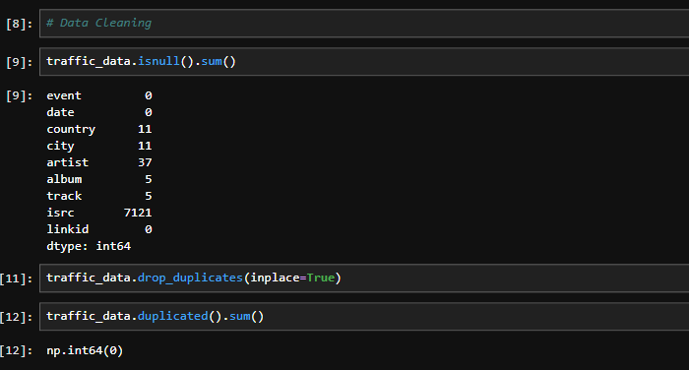
Duplicate Records Check


Dataset Information
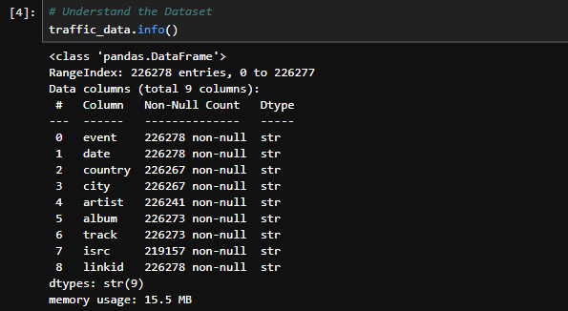

Visualizations

1. Event Distribution
Shows the distribution of pageviews, previews, and clicks.
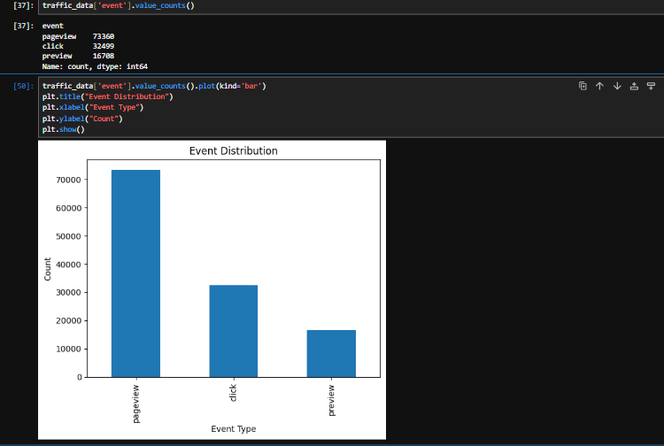

Observation:
Pageviews constitute the majority of user interactions.

2. Daily Traffic Trend
Displays traffic activity over time.
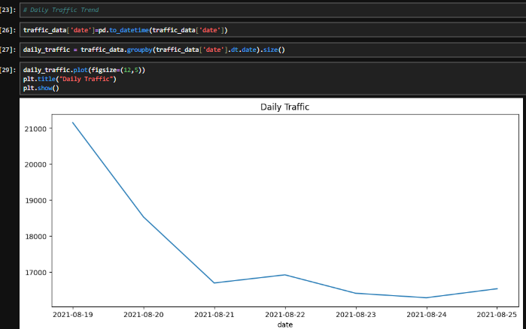

Observation:
Traffic fluctuates across dates with noticeable peak activity periods.

3. Top 10 Countries
Shows countries generating the highest traffic.
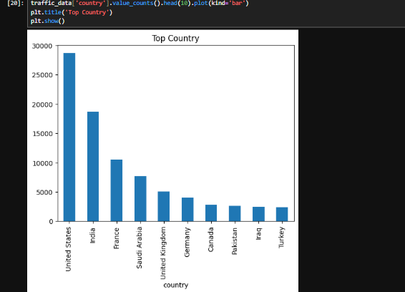

Observation:
A small number of countries contribute most of the traffic volume.

4. Top 10 Cities
Displays the most active cities.
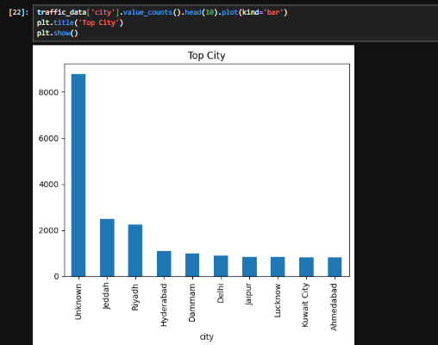

Observation:
Traffic is concentrated in several key cities.

5. Top Artists
Shows artists receiving the highest engagement.
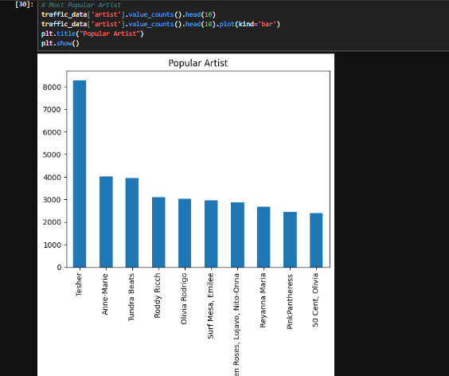

Observation:
A few artists dominate user engagement.

6. Top Tracks
Displays tracks with the highest interaction counts.
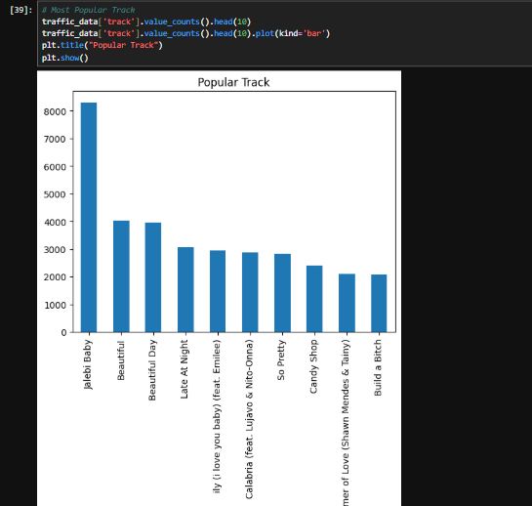

Observation:
Popular tracks receive significantly higher traffic and clicks.

Conversion Analysis

Pageviews, Previews and Clicks
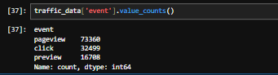

Conversion Metrics
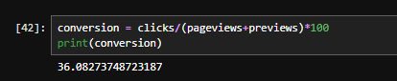

Observation
The conversion funnel demonstrates a drop-off between pageviews and clicks, indicating opportunities to improve user engagement and conversion rates.

Key Insights
- Pageviews account for the majority of user interactions.
- User engagement decreases significantly from pageview to click events.
- Traffic is concentrated in a limited number of countries and cities.
- A small number of artists and tracks generate most of the engagement.
- Conversion opportunities exist within the user journey funnel.

Recommendations
- Improve call-to-action buttons to increase click-through rates.
- Optimize high-traffic landing pages for better engagement.
- Focus marketing campaigns on top-performing countries.
- Promote high-performing artists and tracks more aggressively.
- Conduct A/B testing to improve conversion performance.

Conclusion
The website traffic analysis successfully identified user engagement patterns, content performance, and conversion opportunities. The findings provide valuable insights that can help improve user experience, increase engagement, and optimize conversion rates through targeted business strategies.

